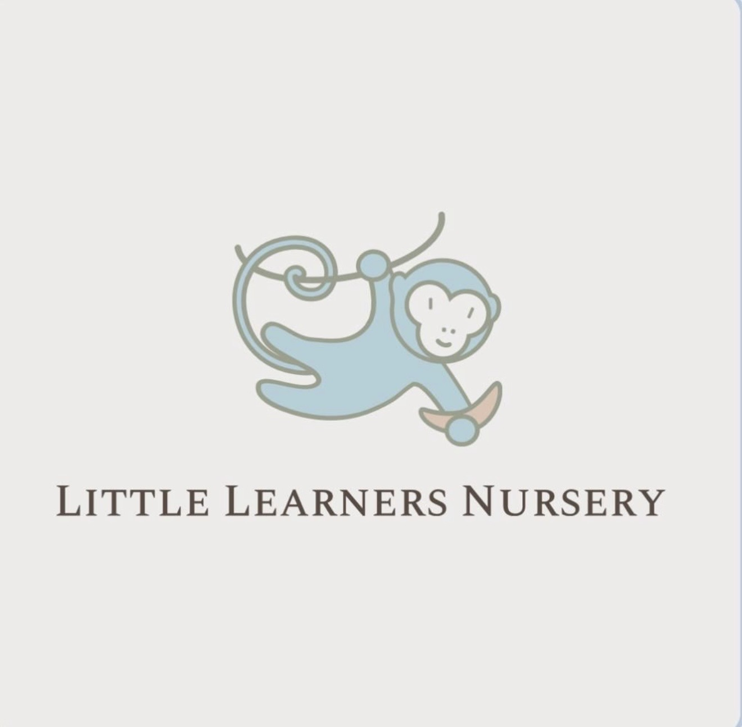
LITTLE LEARNERS NURSERY
🔢 Early Maths – Easy Activities at Home
Early maths is about exploring numbers, shapes, patterns and problem-solving through everyday play. Simple activities at home help children build confidence with maths as they prepare for school.
🔢 Count Together
• Count toys, steps or snacks during daily routines.
• Use fingers, claps or jumps to make counting fun.
🍎 Use Everyday Moments
• Talk about big/small, more/less or full/empty.
• Let children help measure while cooking.
🧩 Explore Shapes and Patterns
• Look for shapes around the home.
• Create simple colour or movement patterns.
🎲 Learn Through Play
• Play board games with dice.
• Sort objects by colour, size or type.
😊 Keep It Fun
• Praise effort and curiosity.
• Focus on exploring rather than getting answers right.
Everyday maths talk helps children build confidence and develop a positive attitude towards learning.

