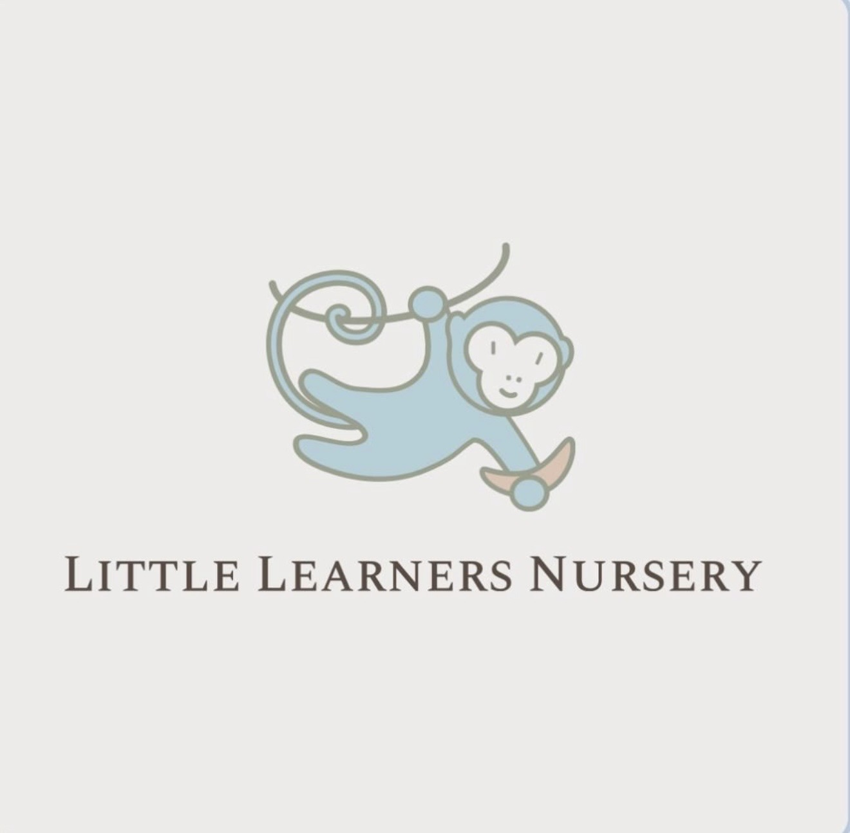
LITTLE LEARNERS NURSERY
🌟 Independence – Easy Activities at Home
Developing independence helps children feel confident, capable and ready for everyday routines when they start school. Small opportunities at home allow children to practise doing things for themselves and build important life skills.
👕 Encourage Self‑Care Skills
• Practise putting on coats, shoes and simple clothing.
• Support children to use the toilet, wash hands and manage their belongings.
• Give children time to try before stepping in to help.
🧸 Involve Children in Daily Routines
• Encourage tidying toys, setting the table or helping with small jobs.
• Offer simple choices like “red cup or blue cup?”
• Create predictable morning and bedtime routines.
🥄 Support Mealtime Independence
• Encourage children to feed themselves using child‑friendly cutlery.
• Practise opening lunchboxes or drink bottles.
• Allow small spills — learning takes practice.
👍 Build Confidence Through Responsibility
• Praise effort: “You tried really hard to do that yourself!”
• Break tasks into small steps to help children succeed.
• Let children attempt tasks before offering help.
😊 Keep It Positive and Patient
• Independence grows with encouragement and time.
• Stay calm and supportive when tasks feel tricky.
• Celebrate small achievements to build confidence.
Giving children opportunities to do things for themselves helps them grow in confidence, resilience and independence as they get ready for school.

